**Use GIT as local VCS. Steps to follow:**

**1. Create a directory ‘project_dir’ & cd to ‘project_dir’.**

mkdir project_dir & cd project_dir

**2. Initialize git version database. (git init)**

git init

**3. Create a new file index.html.**

touch index.html

**4. Check the git status. You should find index.html as untracked file.**

git status

**5. Stage the index.html file.**

git add index.html

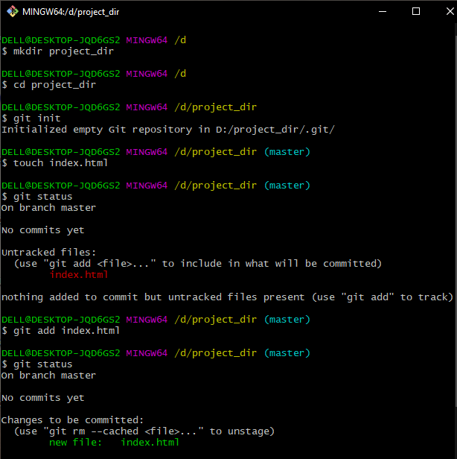

**6. Commit index.html**

git commit –m “commit index html”

**7. Make few changes in index.html & create a new file info.txt file.**

touch info.txt

**8. Check git status. You should find index.html & info.txt as untracked files.**

git status

**9. Configure GIT to ignore all txt files.**

touch .gitignore

**10. Again check the git status. You should find only index.html as untracked file.**

git status

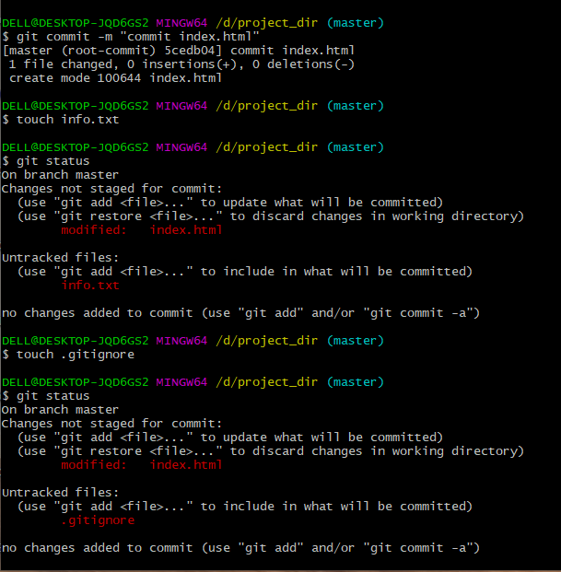

**11. State & commit index.html**

**g**it add index.html

**12. Log all your comments so far.**

git log

**13. Make some changes in index.html.**

**14. Revert the change made in the previous step using git command.**

git checkout -- index.html

**15. Again change index.html.**

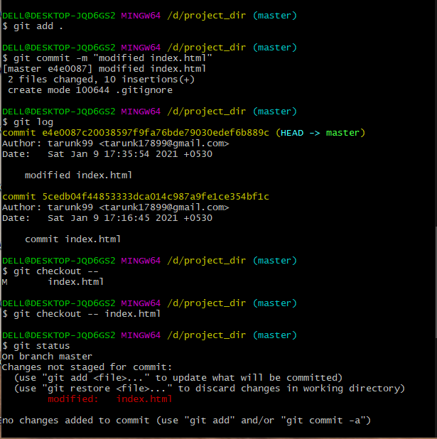

**16. Stage index.html**

git add index.html

**17. Revert back the last stage.**

**g**it restore –staged inex.html

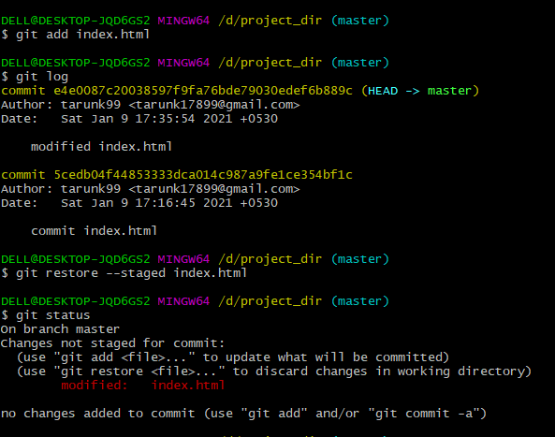

**18. Rename ‘add’ command to ‘my-add’.**

git config –global alias.my-add ‘add’

**19. Using my_add command Stage index.html again & commit the changes.**

git my-add index.html

**20. Revert the last commit.**

git revert “id of last commit”

